**Connecting Peers : Unveiling the Power of Peer-to-Peer File Sharing**

Project submitted to the

SRM University – AP, Andhra Pradesh

for the partial fulfillment of the requirements to award the degree of

**Bachelor of Technology/Master of Technology**

In

**Computer Science and Engineering**

**School of Engineering and Sciences**

Submitted by

[nishant kumar | AP22110010245](mailto:nishant_kumar@srmap.edu.in)

[viswanadha sai nissankararao | ap22110010221](mailto:viswanadhasai_nissankararao@srmap.edu.in)

Under the Guidance of

**Kavitha Rani Karnena**

**SRM University–AP**

**Neerukonda, Mangalagiri, Guntur**

**Andhra Pradesh – 522 240**

**[ December , 2023 ]**

# Certificate

Date: 12-Dec-23

This is to certify that the work present in this Project entitled “**Connecting Peers : Unveiling the Power of Peer-to-Peer File Sharing**” has been carried out by **NISHANT KUMAR** AND **VISWANADHA SAI.N** under my/our supervision. The work is genuine, original, and suitable for submission to the SRM University – AP for the award of Bachelor of Technology/Master of Technology in **School of Engineering and Sciences**.

**Supervisor**

(Signature)

Prof. / Dr. [Name]

Designation,

Affiliation.

**Co-supervisor**

(Signature)

Prof. / Dr. [Name]

Designation,

Affiliation.

# Acknowledgements

We would like to express our gratitude to the developers of the Socket, OS, and Tkinter libraries, which were instrumental in the implementation of our peer-to-peer (P2P) file sharing application. The Socket library provided the necessary networking interface, the OS library facilitated interaction with the operating system for file-related operations, and the Tkinter library enabled the creation of a user-friendly graphical interface.

We appreciate the simplicity and effectiveness of the sender-receiver model in facilitating file transfer over a network using socket programming. This model, involving a sender responsible for sending the file and a receiver responsible for receiving it, proved to be easy to implement and widely applicable.

We acknowledge the valuable input from our users, whose interactions with the application on both the sender and receiver sides have been crucial in its development and improvement. Their feedback on the file selection process, initiation of file transfer, and the status display has greatly contributed to enhancing the user experience.

# Table of Contents

Certificate 3

Acknowledgements 4

Table of Contents 5

Abstract 7

Abbreviations 8

1.Introduction 9

1.1 Decentralization 9

1.2 Implementation through Socket Programming 10

1.3 Utilizing Libraries for Seamless Integration 10

1.4 File Transfer Process 10

1.5 Sender and Receiver Code Components 11

1.6 Support for Various File Types 11

1.7 Conclusion and Future Endeavors 11

2. Methodology 12

2.1 Exploring Peer-to-Peer (P2P) Network Dynamics 12

2.1.1 Peer-to-Peer (P2P) Network Architecture 12

2.1.2 Working of a P2P Network 13

2.1.3 Ensuring Efficient Use of a P2P Network 13

2.1.4 Applications of P2P Network 14

2.1.5 Advantages of P2P File Sharing 15

2.1.6 Disadvantages or Security Issues in Peer-to-Peer File Sharing 17

2.2 Methodology 19

2.2.1 File Sharing Mechanism 19

2.2.2 Establishing Connection 20

2.2.3 User Input 20

2.2.4 Sending and Receiving Data 21

2.2.5 Closing Connection 22

2.2.6 Sender Side Code Components 22

2.2.7 Receiver Side Interactions 22

2.2.8 Supported File Types 22

Concluding Remarks 24

Future Work 26

1. Wide Area Network (WAN) Implementation: 26

2. Security Measures Implementation: 26

3. Multi-User Collaboration: 27

4. High-Speed File Transfer: 27

5. User Interface Enhancements: 27

6. Performance Monitoring and Optimization: 28

7. Scalability Improvements: 28

8. User Education and Documentation: 28

9. Testing and Quality Assurance: 29

References 30

1. P2P File Sharing Concepts: 30

2. Socket Programming: 30

3. Tkinter Library: 30

4. P2P Network Dynamics: 30

5. Advantages and Disadvantages of P2P File Sharing: 30

6. Security in P2P File Sharing: 30

# Abstract

This report presents a detailed analysis of a peer-to-peer (P2P) file sharing application based on the sender-receiver model using socket programming. The application leverages several libraries including Socket, OS, and Tkinter to facilitate file transfer between two entities: a sender and a receiver.

The Socket library provides the necessary networking interface, while the OS library interacts with the operating system to handle file-related operations. The Tkinter library is used to create a user-friendly graphical interface.

The process of file transfer involves establishing a connection, taking user input for file selection and destination directory, transferring the data, and finally, closing the connection.

The sender side code components include socket initialization, file selection, and file transfer. The user interactions on the sender side involve file selection and initiating the transfer. On the receiver side, the user initiates the transfer and selects the destination for the received file.

The application supports various file types including text files (e.g., .txt, .doc, .docx, .pdf) and image files (e.g., .jpg, .png, .gif). Future improvements and enhancements to the application are also discussed.

# Abbreviations

1. **P2P**: Peer-to-Peer
2. **GUI**: Graphical User Interface
3. **OS**: Operating System
4. **.txt**: Text File
5. **.doc**: Microsoft Word Document
6. **.docx**: Microsoft Word Document
7. **.pdf**: Portable Document Format
8. **.jpg**: Joint Photographic Experts Group
9. **.png**: Portable Network Graphics
10. **.gif**: Graphics Interchange Format
11. **LAN**: Local Area Network
12. **TCP**: Transmission Control Protocol
13. **IP**: Internet Protocol
14. **FTP**: File Transfer Protocol
15. **HTTP**: Hypertext Transfer Protocol
16. **P2P**: Peer-to-Peer
17. **WLAN**: Wireless Local Area Network
18. **WAN**: Wide Area Network
19. **RTP**: Real-time Transport Protocol
20. **GUI**: Graphical User Interface
21. **CLI**: Command Line Interface
22. **HTTPS**: HTTP Secure
23. **FTP**: File Transfer Protocol
24. **TCP**: Transmission Control Protocol
25. **UDP**: User Datagram Protocol
26. **IP**: Internet Protocol
27. **IPv4**: Internet Protocol version 4
28. **IPv6**: Internet Protocol version 6
29. **LAN**: Local Area Network
30. **WAN**: Wide Area Network
31. **WLAN**: Wireless Local Area Network

# 1.Introduction

The sender-receiver model, a fundamental concept in network communication, is the cornerstone of our innovative peer-to-peer (P2P) file sharing application. This model revolutionizes traditional client-server paradigms by casting each user in the P2P network as both a client (receiver) and a server (sender), fostering a highly decentralized network.

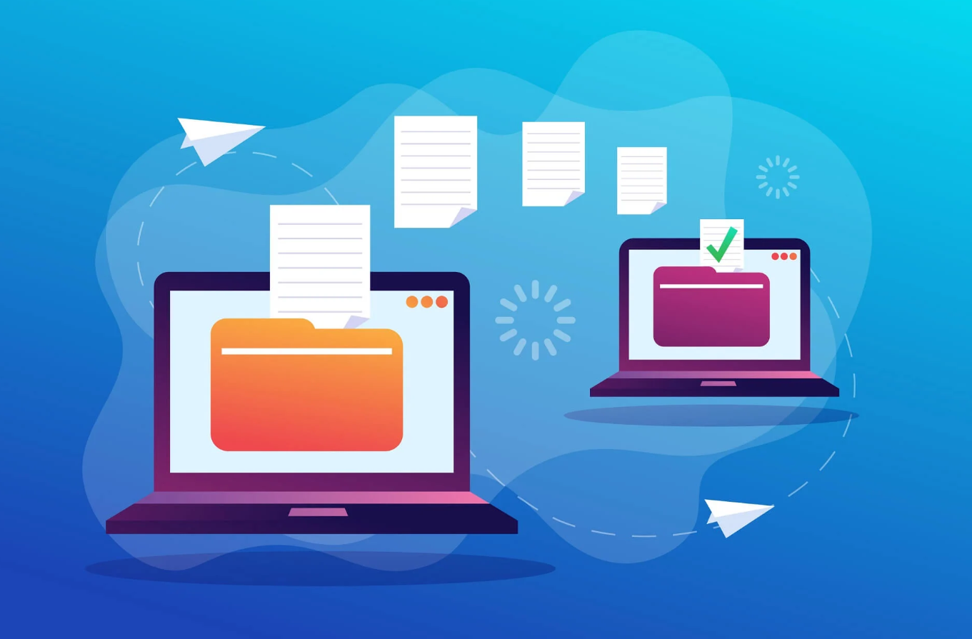

## 

## 1.1 Decentralization

This departure from the conventional centralized model brings numerous advantages. Scalability is significantly improved, as the load is distributed among multiple peers, mitigating the risk of a single bottlenecked server. The decentralized nature enhances system resilience, eliminating a single point of failure. If one peer encounters issues, the others can seamlessly continue sharing files. Moreover, the potential for faster data transfers arises with the increasing number of peers, as each peer can contribute by sharing different pieces of the file simultaneously.

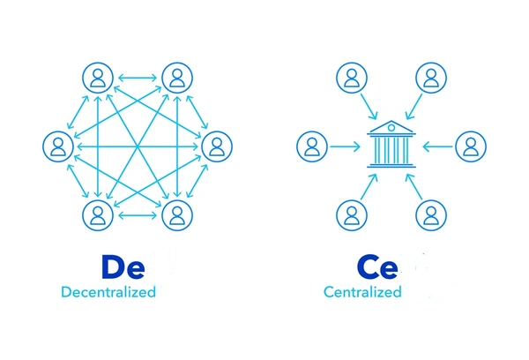

## 1.2 Implementation through Socket Programming

The implementation of the sender-receiver model is orchestrated through socket programming, a powerful tool providing a low-level networking interface for communication between the sender and receiver. The process initiates with the sender establishing a connection, which the receiver actively listens for and accepts. Once the connection is established, a communication channel opens, enabling the seamless transfer of files between peers.

## 1.3 Utilizing Libraries for Seamless Integration

To streamline this intricate process, our application employs several libraries. The Socket library facilitates the networking interface, while the OS library interacts with the operating system to handle file-related operations. Additionally, the Tkinter library contributes to creating a user-friendly graphical interface, enhancing the overall user experience.

## 1.4 File Transfer Process

The file transfer process involves a series of well-defined steps. After establishing a connection, the sender prompts the user to input the file path for the file they wish to send, while the receiver concurrently prompts the user to specify the directory for saving the received file. Subsequently, the sender reads the file and transmits it to the receiver through the established connection. The receiver, in turn, receives the data and writes it to the specified directory. Upon the completion of the file transfer, the connection is promptly closed.

## 1.5 Sender and Receiver Code Components

Delving into the code components, the sender-side comprises socket initialization, file selection, and the file transfer mechanism. The user is required to select the desired file using the browse button, initiating the transfer by clicking on the send button. On the receiver side, the user triggers the transfer by clicking on the receive button.

## 1.6 Support for Various File Types

Our application exhibits versatility by supporting a myriad of file types, including text files (.txt, .doc, .docx, .pdf) and image files (.jpg, .png, .gif). This flexibility empowers users to share a diverse range of content, elevating the utility and applicability of the P2P file sharing application.

## 1.7 Conclusion and Future Endeavors

In conclusion, the sender-receiver model, implemented through socket programming, emerges as the bedrock of P2P file sharing applications. Its simplicity, ease of implementation, and the array of advantages it offers over traditional file-sharing methods render it a popular choice for digital content distribution. As we continue to delve into the intricate details of this model, exploring the libraries used, the project workflow, the sender and receiver side code components, user interactions, file transfer mechanisms, and the supported file types, we envision unlocking even more of its untapped potential. The subsequent sections of this report will provide an in-depth exploration of these aspects, shedding light on the intricacies and offering suggestions for future improvements. The ongoing evolution of the sender-receiver model in our application reflects our commitment to innovation and user-centric design.

# 2. Methodology

## 2.1 Exploring Peer-to-Peer (P2P) Network Dynamics

### 2.1.1 Peer-to-Peer (P2P) Network Architecture

In the architecture of a Peer-to-Peer (P2P) network, computers connect with each other within a workgroup, fostering file sharing, internet access, and printer accessibility.

Every computer within the network holds identical responsibilities and capabilities.

Each device serves as both a client and a server, contributing to the decentralized nature of the network.

Particularly beneficial in residential areas, small offices, or smaller companies where each computer functions as an independent workstation, storing data locally on its hard drive.

Each computer possesses the ability to share data seamlessly with others in the network.

Typically composed of workgroups, each consisting of 12 or more interconnected computers.

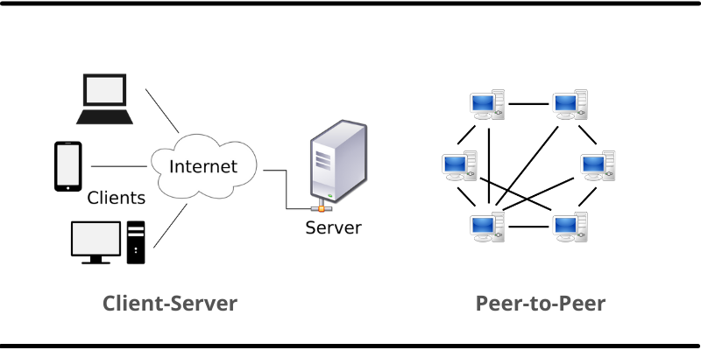

### 2.1.2 Working of a P2P Network

To comprehend the functioning of a Peer-to-Peer network, let's consider the process of file download:

Installation of P2P Software: If not already installed, users install P2P software on their computers, creating a virtual network of P2P application users.

File Download Process: Users download files in bits from multiple computers in the network that already have the file.

Bidirectional Data Transfer: Data is sent from the user's computer to others in the network requesting data existing on the user's computer.

Load Distribution: The file transfer load is distributed among peer computers in the P2P network.

### 2.1.3 Ensuring Efficient Use of a P2P Network

To utilize a P2P network efficiently, implement the following measures:

**Network Security:**

Share and download only legal files, ensuring compliance.

Design a strategy aligned with the network's architecture to manage applications and data effectively.

Keep security practices up-to-date, investing in robust software to prevent network exploitation.

**File Scanning and Privacy Measures:**

Constantly scan files for viruses before downloading.

Ensure proper shutdown of P2P networking post-use to prevent unauthorized access.

### 2.1.4 Applications of P2P Network

P2P networks find applications in various domains:

**File Sharing:**

P2P network serves as a convenient, cost-efficient method for businesses to share files without the need for intermediate servers.

**Blockchain:**

P2P architecture aligns with decentralization principles, proving valuable in blockchain networks for maintaining accurate and secure data records.



**Direct Messaging and Collaboration:**

P2P networks provide a secure and efficient platform for direct messaging and collaboration among peers.

**Content Distribution:**

Unlike client-server systems, P2P networks allow both providing and using resources, enhancing content-serving capacity as user numbers increase.

**IP Telephony:**

P2P applications like Skype exemplify the use of P2P architecture in VoIP (Voice over Internet Protocol).

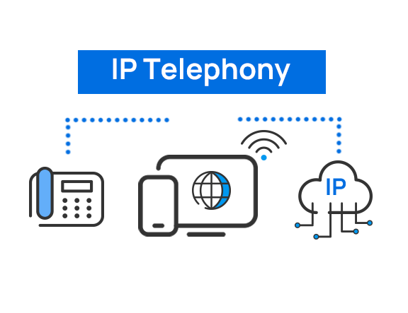

### 2.1.5 Advantages of P2P File Sharing

1. **Decentralization and Scalability:** P2P networks are decentralized, meaning there’s no single point of failure. As more devices join the network, its capacity and scalability increase, ensuring smoother and more efficient operations even under high loads.
2. **Resource Sharing and Efficiency:** P2P networks facilitate seamless sharing of resources, such as files, processing power, and bandwidth, among connected devices. This decentralized sharing model optimizes resource utilization, leading to improved efficiency and reduced overall costs.
3. **Redundancy and Fault Tolerance:** If one node fails or leaves the network, the distributed nature of the system ensures that other nodes can still access the required resources or information, reducing the risk of data loss or service interruption.
4. **Enhanced Privacy and Security:** In P2P networks, data is directly shared between peers, eliminating the need for intermediaries or third-party servers. This direct communication enhances privacy by reducing the exposure of sensitive information to external entities.
5. **Easy File Sharing:** P2P networks make it easy to share files directly between users without the need for a central server.
6. **Reduced Costs:** Since P2P networks don’t require a central server, they can significantly reduce overhead costs for large organizations.
7. **Adaptability:** P2P networks can easily adapt to changes in the network, such as the addition or removal of nodes.
8. **Reliability:** The decentralized nature of P2P networks makes them highly reliable. Even if one node fails, the network as a whole can continue to function.
9. **High Performance:** By leveraging the resources of multiple peers, P2P networks can often provide higher performance than traditional client-server networks.
10. **Efficiency:** P2P networks are often more efficient than traditional networks because they use resources more effectively and eliminate bottlenecks associated with central servers.

### 2.1.6 Disadvantages or Security Issues in Peer-to-Peer File Sharing

1. **Risk of Unauthorized Access:** Despite implementing robust access controls and authentication mechanisms, there’s always a risk of unauthorized access to sensitive information.
2. **Data Security During Transit:** Even though encryption techniques like SSL or TLS are used, data can still be vulnerable during transit between peers.
3. **Potential for Data Loss:** Despite employing data loss prevention tools, there’s always a risk of unauthorized transmission of sensitive data outside the network.

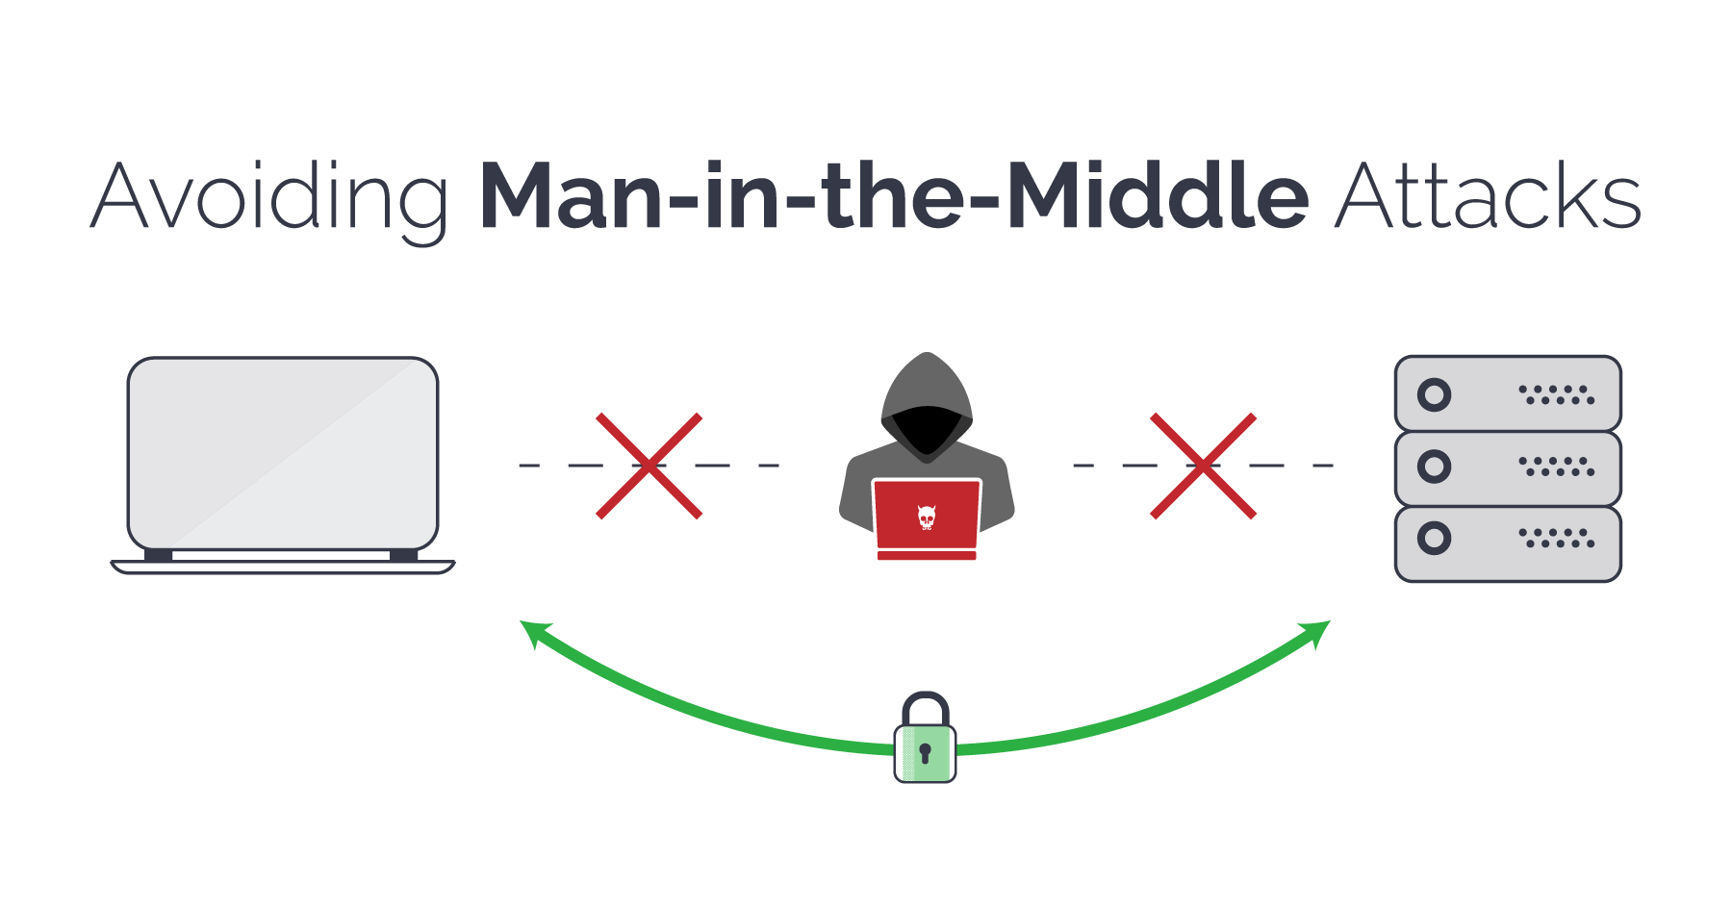

1. **Network Segmentation Complexity:** Implementing network segmentation to limit the impact of a security breach can be complex and difficult to manage.
2. **Regular Audits Requirement:** Conducting regular reviews and audits of the network to identify potential security threats requires additional resources and can be time-consuming.
3. **Lack of Central Organization:** Files or resources are not centrally organized in a P2P network, which can make it difficult to locate specific files.
4. **Increased Risk of Viruses:** P2P networks can increase the risk of introducing viruses into your system.
5. **Copyright Infringements:** There is a risk of copyright infringements, as many P2P networks have been banned in the past due to such issues.
6. **Lack of Security:** P2P networks often lack robust security measures, making them vulnerable to cyber attacks.

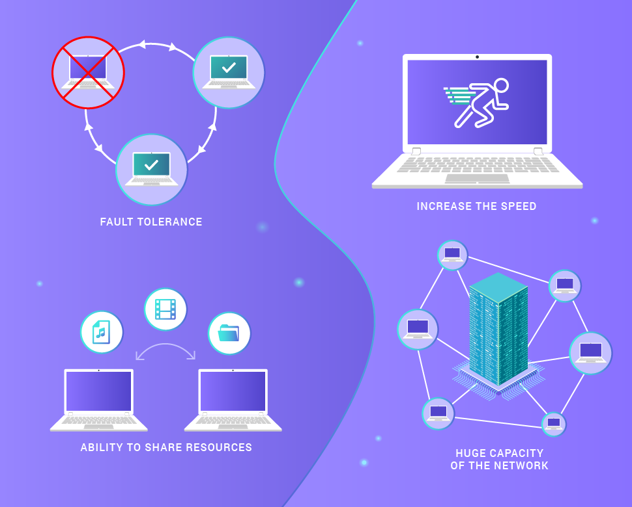

1. **No Reliable Backup System:** P2P file sharing does not have a reliable backup system. In contrast, other file-sharing networks have dedicated central servers to back up files.

## 2.2 Methodology

The methodology employed in the development and implementation of our peer-to-peer (P2P) file sharing application is deeply rooted in the robust and versatile sender-receiver model, leveraging the power of socket programming. This model serves as the linchpin of P2P file sharing applications, ushering in a paradigm shift in the landscape of digital content distribution.

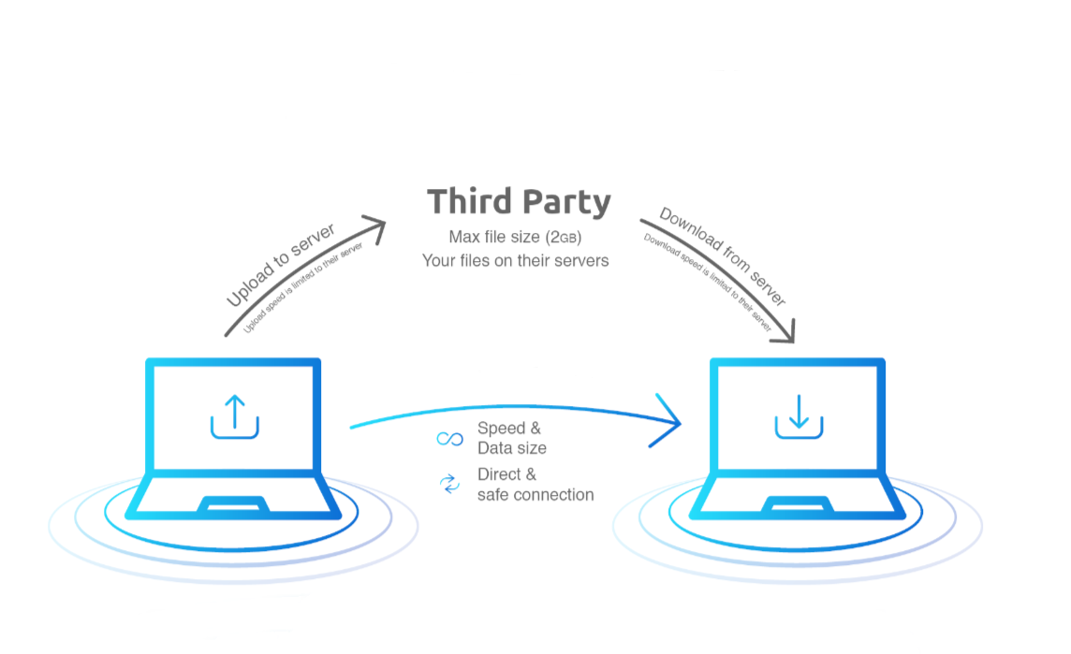

### 2.2.1 File Sharing Mechanism

In contrast to traditional client-server models, the file sharing mechanism in a P2P network is inherently decentralized. Every user, or 'peer,' fulfills the dual roles of a client (receiver) and a server (sender), contributing to the highly distributed nature of the network. This decentralization bestows a multitude of advantages, including enhanced scalability, resilience against failures, and the potential for accelerated data transfers as the peer count increases.

When a peer seeks to download a file, it initiates a request within the network. Subsequently, the P2P software program orchestrates a search across connected computers to pinpoint the desired content. Once located, the file transfer ensues directly between the requesting peer and the peer possessing the sought-after file.

### 2.2.2 Establishing Connection

The foundational step in the file-sharing process is the establishment of a connection between the sender and the receiver. Leveraging the socket library, the sender initiates the connection, thereby providing the low-level networking interface required for seamless communication. Concurrently, the receiver actively listens for incoming connections and gracefully accepts the connection request from the sender. This established connection serves as the conduit through which sender and receiver can engage in the transfer of files.

### 2.2.3 User Input

Moving forward, the next crucial step involves user input. The sender, facilitated by the Tkinter library, prompts the user to input the file path of the intended file for transfer. Tkinter, with its graphical user interface (GUI) capabilities, streamlines the process of file selection, enhancing the overall user experience. Simultaneously, the receiver prompts the user to specify the directory where the received file should be stored.

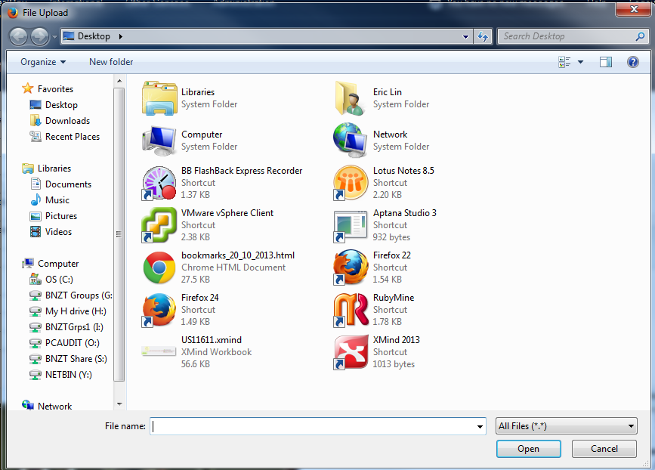

### 2.2.4 Sending and Receiving Data

The heart of the file transfer process unfolds in the subsequent step. The sender, after reading the designated file, initiates its transmission to the receiver through the established connection. Here, the OS library comes into play, interacting with the operating system to retrieve crucial information such as the file size and checking for the file's existence before commencing the transfer. The receiver, on the other end, adeptly receives the data and meticulously writes it to the specified directory.

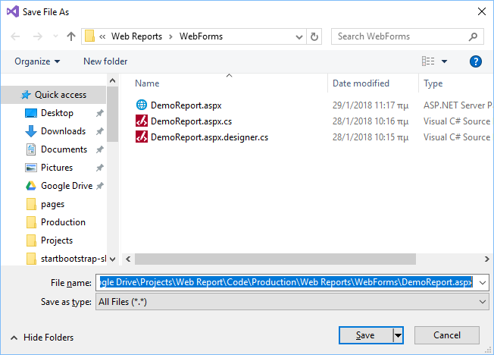

### 2.2.5 Closing Connection

Upon the completion of the file transfer, the sender and receiver execute the crucial step of closing the connection, facilitated once again by the socket library. This marks the conclusion of one cycle within the sender-receiver model.

### 2.2.6 Sender Side Code Components

For the sender side, the code components encompass socket initialization, file selection, and file transfer mechanisms. User interaction involves selecting the desired file through the browse button, followed by initiating the transfer with a click on the send button.

### 2.2.7 Receiver Side Interactions

On the receiver side, user interaction is initiated by clicking on the receive button to commence the transfer. A progress bar provides real-time feedback on the status of the ongoing file transfer.

### 2.2.8 Supported File Types

The application boasts support for a diverse array of file types, including but not limited to text files (e.g., .txt, .doc, .docx, .pdf) and image files (e.g., .jpg, .png, .gif). This expansive support extends the utility of the application, empowering users to share an extensive range of content across the P2P network.

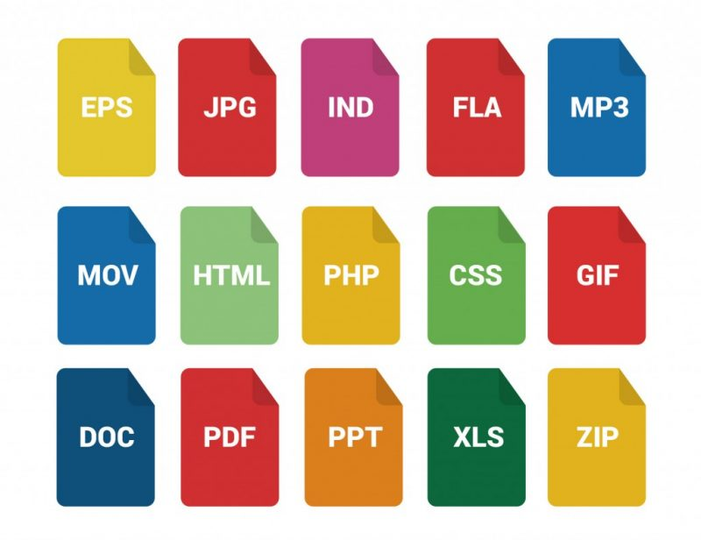

In conclusion, the sender-receiver model, implemented through the robust framework of socket programming, stands as the bedrock of P2P file sharing applications. Its simplicity, ease of implementation, and the manifold advantages it offers over traditional file sharing methods underscore its popularity in the realm of digital content distribution. As we embark on a continuous journey of exploration and refinement of this model, we anticipate unlocking even greater potential within its framework.

# Concluding Remarks

In conclusion, the sender-receiver model, implemented through the powerful framework of socket programming, serves as the foundational structure of our innovative peer-to-peer (P2P) file sharing application. Departing from traditional client-server paradigms, our approach embraces decentralization, with each user acting as both a client and a server, fostering a highly distributed network. This departure brings forth numerous advantages, including enhanced scalability, improved system resilience, and the potential for faster data transfers as the peer count increases.

The implementation details reveal the orchestration of the sender-receiver model through socket programming, creating a low-level networking interface for seamless communication. The utilization of libraries, such as Socket, OS, and Tkinter, streamlines the intricate process, enhancing the overall user experience and facilitating a smooth file transfer mechanism.

Our application's support for various file types, including text and image files, showcases its versatility and broadens its utility across a diverse range of content. This flexibility empowers users to share files seamlessly within the P2P network, contributing to the application's appeal and practicality.

In the methodology section, we explored the dynamics of peer-to-peer (P2P) networks, emphasizing their decentralized architecture and illustrating their efficient file-sharing mechanisms. The advantages of P2P file sharing, such as decentralization, resource sharing, redundancy, and adaptability, were highlighted, while acknowledging potential security concerns and disadvantages associated with unauthorized access and data vulnerability.

The detailed methodology employed in the development of our P2P file sharing application showcased the file-sharing mechanism, connection establishment, user input processes, and the crucial steps of sending, receiving, and closing the connection. The sender and receiver side code components, along with supported file types, were outlined, providing a comprehensive understanding of the application's functionality.

As we conclude this report, the ongoing evolution of the sender-receiver model in our application reflects a commitment to innovation and user-centric design. The exploration of intricate details, libraries used, code components, user interactions, and file transfer mechanisms lays the foundation for future improvements. Through continuous refinement and exploration, we aim to unlock even greater potential within the sender-receiver model, reaffirming its significance in the landscape of digital content distribution.

# Future Work

## 1. **Wide Area Network (WAN) Implementation:**

* Objective: Extend the existing Local Area Network (LAN) functionality to operate over a Wide Area Network (WAN), allowing users to share files across geographical locations.
* Steps:
  + Network Protocol Enhancement: Investigate and adopt network protocols suitable for WAN communication, such as TCP/IP or UDP, to ensure reliable and efficient data transfer over long distances.
  + Addressing and Routing: Implement features to handle addressing and routing across different networks, considering factors like latency and packet loss.
  + Bandwidth Optimization: Develop mechanisms to optimize file transfer for varying bandwidth conditions commonly encountered in WAN environments.

## 2. **Security Measures Implementation:**

* Objective: Enhance the security of the P2P file sharing application to safeguard user data and ensure secure communication.
* Steps:
  + Encryption Implementation: Integrate end-to-end encryption to secure data during transit, ensuring that only the intended sender and receiver can access the shared files.
  + User Authentication: Implement robust user authentication mechanisms to prevent unauthorized access to the application, requiring users to verify their identity before sharing or receiving files.
  + Secure Connection Establishment: Enhance the process of connection establishment by incorporating secure protocols (e.g., TLS) to protect against man-in-the-middle attacks.
  + File Integrity Verification: Implement mechanisms to verify the integrity of received files, using cryptographic hashes or checksums, to ensure that files have not been tampered with during transit.
  + Access Control: Introduce access control mechanisms to regulate file sharing permissions, allowing users to define who can access their shared files.

## 3. **Multi-User Collaboration:**

* Objective: Enable multiple users to collaborate on file sharing activities simultaneously, fostering a more dynamic and collaborative P2P network.
* Steps:
  + Concurrency Handling: Implement concurrency control mechanisms to manage simultaneous file transfers and ensure data consistency.
  + Real-Time Status Updates: Introduce real-time status updates, notifying users about ongoing file transfers and system activities, enhancing the collaborative experience.
  + User Presence Awareness: Implement features to indicate the presence and activity of other users in the P2P network, enhancing communication and collaboration.

## 4. **High-Speed File Transfer:**

* Objective: Improve the efficiency of file transfers by optimizing for high-speed data transmission.
* Steps:
  + Parallel File Transfer: Explore and implement techniques for parallelizing file transfers, allowing the application to leverage the available bandwidth more effectively.
  + Compression Techniques: Integrate file compression techniques to reduce file sizes before transfer, optimizing the use of network resources.
  + Quality of Service (QoS) Integration: Investigate QoS parameters and implement mechanisms to prioritize and streamline high-speed file transfers within the P2P network.

## 5. **User Interface Enhancements:**

* Objective: Improve the user interface to accommodate the new features and provide a seamless experience for users.
* Steps:
  + Intuitive WAN Configuration: Develop a user-friendly interface for configuring WAN settings, guiding users through the process of connecting to a wider network.
  + Security Dashboard: Create a dashboard to display the security status of the application, indicating the level of encryption, authentication status, and recent security events.
  + Collaboration Center: Introduce a centralized space within the interface for users to view ongoing collaborations, shared files, and the activity of other peers in real-time.

## 6. **Performance Monitoring and Optimization:**

* Objective: Implement tools for monitoring the performance of the P2P file sharing application and optimize its efficiency.
* Steps:
  + Performance Metrics: Integrate performance monitoring tools to track factors such as transfer speed, latency, and resource utilization.
  + Automated Optimization: Implement automated processes to optimize the application's settings based on real-time performance metrics, ensuring optimal performance under varying conditions.
  + User Feedback Mechanism: Establish a feedback mechanism for users to report performance issues, facilitating continuous improvement.

## 7. **Scalability Improvements:**

* Objective: Enhance the scalability of the P2P file sharing application to accommodate a growing number of users and files.
* Steps:
  + Load Balancing: Implement load balancing mechanisms to distribute file-sharing loads evenly across multiple servers or peers, preventing bottlenecks.
  + Dynamic Resource Allocation: Develop algorithms for dynamically allocating resources based on the current network conditions and user activity.
  + Efficient Resource Discovery: Improve mechanisms for discovering and connecting with peers in the WAN, ensuring efficient utilization of available resources.

## 8. **User Education and Documentation:**

* Objective: Provide comprehensive documentation and educational materials to guide users in configuring and utilizing the upgraded features of the P2P file sharing application.
* Steps:
  + User Manuals: Create user manuals and documentation explaining the new WAN functionality, security features, collaboration options, and performance optimization tips.
  + Tutorials and Training: Develop video tutorials or interactive training modules to assist users in understanding and making the most of the enhanced application features.

## 9. **Testing and Quality Assurance:**

* Objective: Conduct thorough testing of the upgraded P2P file sharing application to identify and address potential issues, ensuring a reliable and secure user experience.
* Steps:
  + Security Audits: Perform regular security audits to identify vulnerabilities and address potential security risks.
  + Performance Testing: Conduct performance testing under various scenarios to ensure the application's responsiveness and stability.
  + User Acceptance Testing (UAT): Engage users in UAT sessions to gather feedback on the upgraded features and make necessary adjustments.

By addressing these future work items, the P2P file sharing application can evolve into a robust, secure, and feature-rich solution, meeting the demands of users in both LAN and WAN environments.

# References

## P2P File Sharing Concepts:

* 1. Baran, P. (1964). On Distributed Communications Networks. *IEEE Transactions on Communications Systems*, 12(1), 1-9.
  2. Cohen, B. (2003). Incentives Build Robustness in BitTorrent. *Workshop on Economics of Peer-to-Peer Systems*, 68-72.
  3. Steinmetz, R., & Wehrle, K. (2005). Engineering P2P Systems. *IEEE Internet Computing*, 9(1), 37-45.

## Socket Programming:

* 1. Comer, D. E. (2003). *Internetworking with TCP/IP: Principles, Protocols, and Architecture*. Prentice Hall.
  2. Stevens, R. W. (1994). *TCP/IP Illustrated, Volume 1: The Protocols*. Addison-Wesley.

## Tkinter Library:

* 1. Grayson, J. M. (2000). *Python and Tkinter Programming*. Manning Publications.
  2. Love, R. (2014). *Tkinter GUI Application Development Blueprints*. Packt Publishing.

## P2P Network Dynamics:

* 1. Ripeanu, M. (2001). Peer-to-peer architecture case study: Gnutella network. *Proceedings of the 22nd IEEE International Conference on Distributed Computing Systems*, 1-10.
  2. Tanenbaum, A. S., & van Steen, M. (2007). *Distributed Systems: Principles and Paradigms*. Pearson.

## Advantages and Disadvantages of P2P File Sharing:

* 1. Ripeanu, M., Foster, I., & Iamnitchi, A. (2002). Mapping the Gnutella Network: Properties of Large-Scale Peer-to-Peer Systems and Implications for System Design. *IEEE Internet Computing*, 6(1), 50-57.
  2. Gupta, A., Li, X., & Schunter, M. (2004). Fair Use of Open Content: A New Copyleft for the Darknet? *International Conference on Information Systems Security*, 368-375.

## Security in P2P File Sharing:

* 1. Douceur, J. R. (2002). The Sybil Attack. *International Workshop on Peer-to-Peer Systems*, 251-260.
  2. Garfinkel, T., & Rosenblum, M. (2005). When Virtual Is Harder than Real: Security Challenges in Virtual Machine Based Computing Environments. *Proceedings of the 10th Workshop on Hot Topics in Operating Systems*, 1-6.